


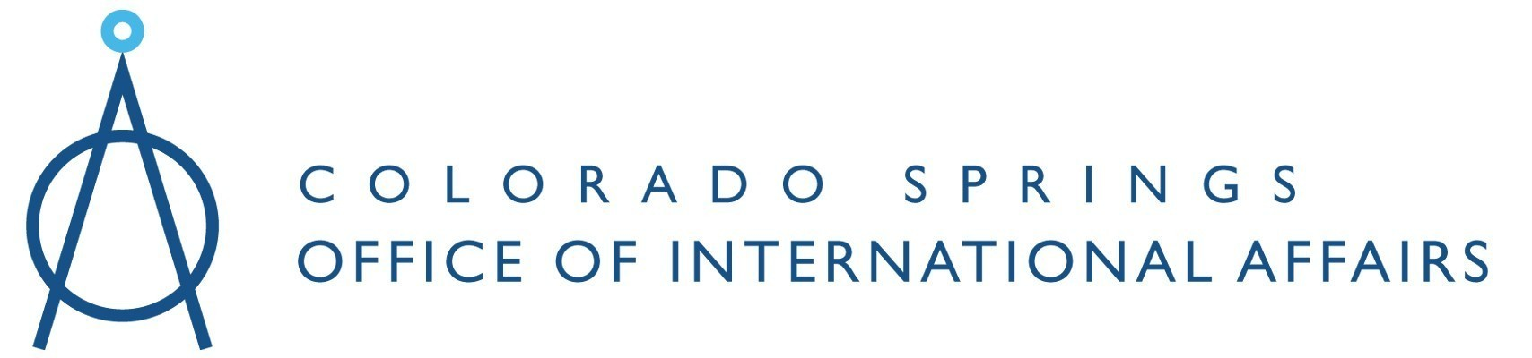

Complying with the ITAR
in a More Invigorated Enforcement Environment

Colorado Springs, CO ~ September 3rd, 2008

AGENDA

7:30 - 8:30 AM Registration & Networking Breakfast
8:30 - 8:45 AM Opening Remarks & Introductions
Paul Bergman, Director, US Commercial Service Denver
John Priecko, Vice President, Global Trade Compliance, JP Morgan

8:45 - 9:45 AM US Export Controls: Overview of the Players, Policies and Processes
Bruce Jackson, Vice President & Exports Practice Leader, JP Morgan

9:45 - 10:00 AM BREAK

10:00 - 11:00 AM Empowered Officials & Trade Compliance Professionals:
Minimizing Exposure, Liability and Risk
John Priecko, Vice President, Global Trade Compliance, JP Morgan

11:00 - 12:00 PM Jurisdiction Determination: The Critical Importance of Getting it Right
Bruce Jackson, Vice President & Exports Practice Leader, JP Morgan

12:00 - 1:30 PM LUNCH (Provided) & Keynote Address by USDOD Defense Security Service

1:30 - 2:30 PM Hot Topics: Changes & Trends at the State Department, Brokering,
Voluntary Disclosures, Third-Country/Dual Nationals, D-Trade, Merger &
Acquisition Due Diligence and much more…
David Glynn, Of Counsel, Holland & Hart
Lizbeth Rodriguez, Of Counsel, Holland & Hart

2:30 - 3:30 PM Industry Panel & Best Practices on How To Successfully Negotiate
the ITAR Minefield
Moderated by: TBD, Holland & Hart
Tom Chapin, Director - Global Trade Controls, United Launch Alliance
Andy Zirkelbach, Senior Attorney, Ball Corporation and VP, Empowered Official,
Ball Aerospace & Technologies Corp
Trish Heller, Rocky Mountain Instrument Co) (Moderator: Trip MacIntosh)

3:30 - 3:45 PM BREAK

Continued…

Complying with the ITAR
in a More Invigorated Enforcement Environment

Colorado Springs, CO ~ September 3rd, 2008

AGENDA

3:45 - 4:45 PM Administrative & Criminal Enforcement Update with the Latest on Directed
Disclosures, Grand Jury Subpoenas, Search Warrants, Issues of Privilege, Investigative Protocols and Negotiated Resolutions
TBD, Holland & Hart

4:45 - 5:15 PM Q&A
David Glynn, Attorney, Holland & Hart
Lizbeth Rodriguez, Attorney, Holland & Hart
Bruce Jackson, Vice President & Exports Practice Leader, JP Morgan
John Priecko, Vice President, Global Trade Compliance, JP Morgan

5:15 - 5:30 PM Closing Remarks
Paul Bergman, Director, US Commercial Service Denver
John Priecko, Vice President, Global Trade Compliance, JP Morgan

5:30-7:30 PM Networking Reception Hosted by Holland & Hart
Join us for a chance to talk to the sponsors and speakers in an informal environment and follow-up with questions from the seminar.

NOTE: The following day, as a courtesy to attendees, the presenters are available to answer ITAR and related questions during one-hour no-cost sessions on a first-come first-served basis. Contact Danielle Dooley, U.S. Export Assistance Center, 303-844-6623 x14 or ddooley@mail.doc.gov for more information or to reserve a time.

